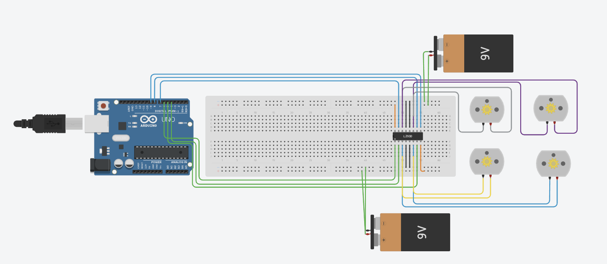Project Gottlieb Circuit Progress New One

1st one with 4DC motors.

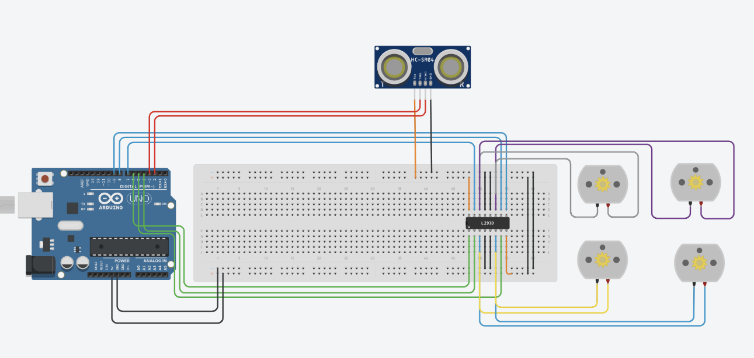2nd one with Ultrasonic and 4 dc motor.

3rd one with LCD Panel, Force sensor, Ultrasonic and 4dc motors.

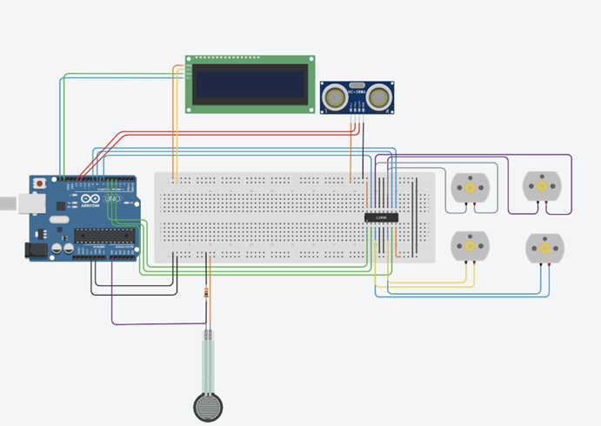

4th one with 2 white LEDS, 3 red LEDS, LCD Panel, Force sensor, Ultrasonic and 4dc motors.

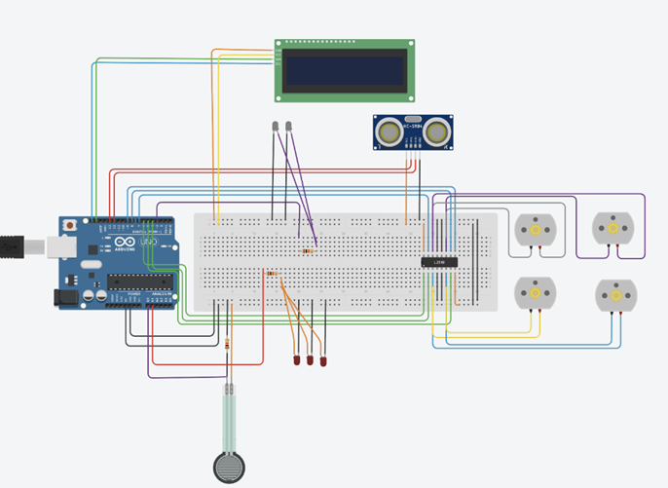

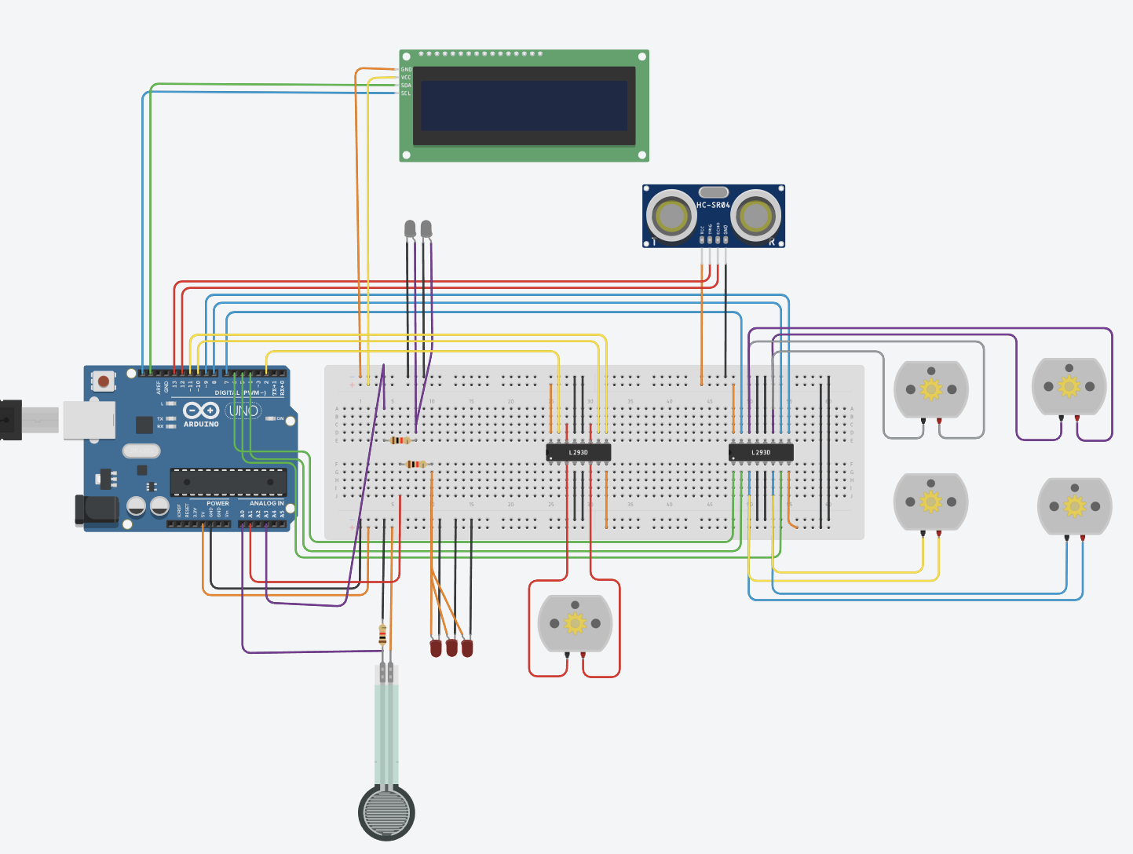5th one with 5th dc motor for bucket, 2 white LEDS, 3 red LEDS, LCD Panel, Force sensor, Ultrasonic and 4dc motors.